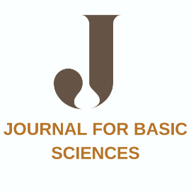

Journal For Basic Sciences

Journal For Basic Sciences
COPYRIGHT FORM
Copyright agreement and authorship responsibility
To,
The Editor,
Journal For Basic Sciences
Dear Sir,
Sub: Submission of an original paper with copyright agreement and authorship responsibility
Topic entitled: ……………………………………………………………………………………………………………….. I certify that I have participated sufficiently in the conception and design of this work and the analysis of the data. I believe the manuscript represents valid work. I have reviewed the final version of the manuscript and approve it for publication. I warrant and represents that the work does not violate any proprietary or personal rights of others (including, without limitation, any copyrights or privacy rights); that the Work is factually accurate and contains no matter libelous or otherwise unlawful; that I have substantially participated in the creation of the work and that is represents my original work sufficient for me to claim authorship. I have the consent of each author to transfer and assign any and all right, title, and interest, including copyright of the article referenced above. Furthermore I attest that I shall produce the data upon which the manuscript is based for examination by the editors or their assignees, if requested. I further confirm that this article has not been published elsewhere, nor is it under consideration by any other publisher.
Thanking you
Yours sincerely,

Author name and address Signature and Date

After completion of this form, please email the scanned file of original signed form to
editorjfbs@gmail.com

